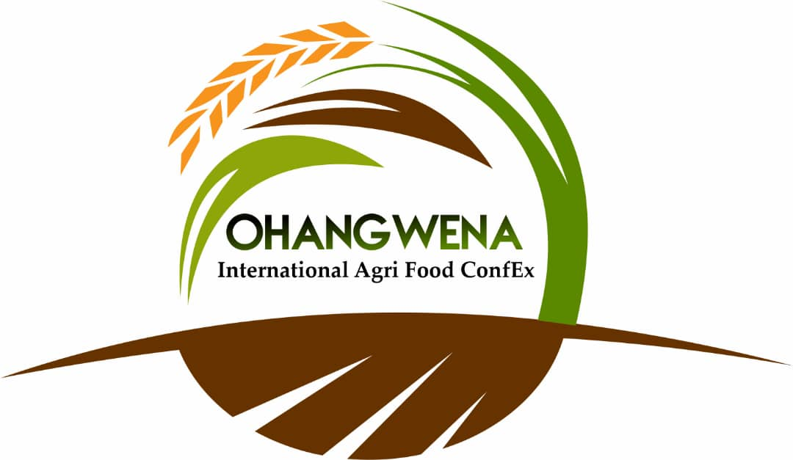

OHANGWENA INTERNATIONAL AGRI-FOOD CONFEX
“Igniting the Ohangwena food basket”

Private Bag 88011, EENHANA│Tel: +24 65 264300 │ Fax: +264 65 263033

10 - 13 August 2022

Convention City: C45 Onhuno- Rundu Road, Eenhana
Ohangwena Region, Namibia

INFORMATION SHEET

Ohangwena Region with the support from World Food Programme will be hosting the 1st of its kind Ohangwena International Agri Food ConfEx from 10 - 13 August 2022 at Eenhana Convention City, Eenhana Town, Namibia.

The Confex offers a platform for a Regional Dialogue to engage stakeholders to examine and shape the future pathway of regional food systems, highlighting complexity, challenges and opportunities, pinpointing the importance of regional coordinated action, and formulating actionable measures towards accelerating food systems transformation in support of the SDGs.

THE HOST TOWN - EENHANA

Eenhana is the capital town of Ohangwena Region in northern Namibia on the border with Angola.
Eenhana is situated in a subtropical forest. It is connected to the road network and has a well-developed infrastructure. Due to the proximity of Angola, many businesses are situated here. The town hosts an annual trade fair.
The name Eenhana comes from the word calves in Oshikwanyama and is a reference to the calves that used to water at the small water pan where Eenhana is now located.

CONFEX AIMS & FOCUS AREAS

A platform to create a platform for conversations to explore and implement innovative and transformation solutions in food productions in the region. Highlight the investments opportunities, capacitate the role players to increase diversification in crops and livestock farming for increase nutritious diets in the region. Make business links to secure access to markets.

Focus areas:
- Increase agricultural productivity in the region
- Crop diversification of high value horticultural crops for the market and meet the needs of the domestic market and export aspirations.
- Economically empower the communal farmers and reduce the dependency of vegetable imports into the region.
- Explore new productive approaches to provide nutritional food to schools and the vulnerable communities.
- Women and Youth development to increase food security
- Post harvesting technologies, market accessibility, financial services and capacity building

WHO CAN EXHIBIT

Categories for the exhibitors:
- Life Stock farmers including (cattle, goat, sheep, poultry), and aquaculture
- Crop farmers (mainly mahangu, maize, black eye beans, ground nuts, and pumpkins and watermelons).
- Nutritionists and value addition producers.
- Technology service providers (processing, packaging), and other related service providers or interest groups
- Small & Medium Enterprises including catering, locally produced products, organic and traditional food and beverages
- Exhibitors or workshops presenters complimenting the focus areas
- Educational institutes
- Financial institutes / investors
- Governing bodies
- Agri-tourism

CONFEX STRUCTURE
Prior and post activities:
- Information sessions to exhibitors to share information to maximize the opportunities
- Ambassadors training – identify support staff to assist with the running of the expo by sharing knowledge.
- Information sessions addressing the current need in the regions building up to the CONFEX
- Pre and post tours to agricultural related projects

Day 1: Wednesday 10 Aug 2022 - Conference and opening of exhibition

Day 2 & 3: Thursday/Friday 11/12 Aug 2022 – Exhibitions, workshops, demonstrations, competitions, information sessions, interactive sessions, entertainment

Day 3: Saturday 13 Aug 2022 – Exhibitions, workshops, demonstrations, competitions, information sessions, interactive sessions, entertainment, awards ceremony

WORKSHOPS

The uniqueness of this ConfEx is the hosting of workshops, demonstrations, and information sessions.

The workshops will include inter-alia: crop production, financial planning, business marketing and market access, value of nutrition, livestock health and marketing, poultry production, horticulture, starting your own backyard vegetable garden, water sanitation and recycling and more.

ACCOMMODATION

The Central Information Centre has available a list of establishments in Eenhana town and the surroundings to cater for your needs.

Please contact the Central Information Centre for assistance.

EXHIBITION FEES

Basic rates | Inside Hall: Corporates and Government per 9m² | N$ 2,800
Basic rates | Outside exhibitors: Corporates and Government per 30m² | N$1,200
Basic rates | SME tent | N$ 500
Basic rates | Open space outside small | N$ 600
Basic rates | Food stalls | N$ 700
Basic rates | SADC | N$ 3,500

IMPORTANT DATES

Opening of applications | Closing of applications | Confirmation to exhibit | Set-up of stall | Start of expo | Dismantle stalls
16 June 2022 | 20 July 2022 | 27 July 2022 | 8 & 9 August 2022 | 10 August 2022 | 13 Aug 2022 after closure of expo

VENUE ACCESSIBILITY

Opening | - The gates open at 08h00-09h00 for Exhibitors only  - The gates open at 09h00 for the public
Closing | - The exhibition halls close at 21h00  - All activities and entertainment shall end at 23h30  - The gates close at 00H00
Entrance fee | - Adults N$10.00  - Children N$5.00  - Vehicle N$10.00  - Schools N$50.00 ( maximum 50 learners)

GENERAL NOTES

- The Central Information Centre will assist with requests and information required regarding application, registration and the logistics of the ConfEx

Conditions:
- Cancellation of stand should be submitted in writing on or after 7th of August 2022. A 50% administration fee shall be payable on this cancellation.
- Refunds on cancelled stands shall be affected after the Expo.
- Food and alcoholic drink Exhibitors must have a valid special Liquor Trading License.
- No applications are to be approved without payments.
- Corporate Entities should provide Purchase Orders with their applications.

CONTACT DETAILS

Central Information Centre

Rauna Ndishishi
Ohangwena Regional Council
Email: rpohamba@ohangwenarc.gov.na
Cell: +264 81 273 0758
FB: Ohangwena Agri Food Expo
Website: www.ohangwenarc.gov.na

Elzene Coetzee
Conference Link
Email: Elzene@conferencelink.com.na
Cell: +264 81 230 4316

